Problem 4:

Data Product:

In this problem, we are analysisng the data for the sales of apartment vs the apartment rentals in the manhattan area.

Here, the sentiment analysis for the tweets that were collected for both the data sets are shown.

Based on the 2 sentiment analysis, we can say that there are more positive results for people looking for apartment rentals than there are to buy apartments.

The below graph is for apartment rentals for which there are more positive tweets:

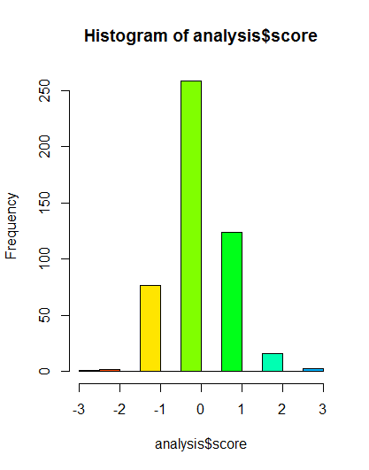

The below graph is for buying of apartments for which there are less number of positive tweets

Equipped with this data, I would pitch my idea to RealDirect that they should start offering rentals in NYC.